[Company Name] Pandemic Action Plan
Table of Contents
1. Purpose of plan 2
2. Potential effects of pandemic 2
3. Impact of a pandemic on services and supplies 2
4. Managing a pandemic 3
5. Protection of [COMPANY NAME] staff and clients 3
6. Staff obligation to protect themselves and others 4
7. Protection measures: 5
8. Active phase of the pandemic 6
9. Specialised cleaning 6
10. Keyboards and phones 7
11. Kitchen hygiene/break-out area hygiene 7
12. Bathroom hygiene 7
13. Personal Protective Equipment (PPE) 8
14. Communication 8
15. Restricting workplace entry of people with virus symptoms 8
16. Social distancing 9
17. Contact management 9
Appendix 1 11
18. How to clean the workplace during a pandemic 11
Overview 11
19. Cleaning/hygiene equipment and supplies 12
20. Staff use 12
Cleaning Products 12
21. Bleach as a Disinfectant 13
Appendix 2 14
22. Recommended technique for good hand hygiene practice 14
Appendix 5 19
23. Screening flowchart 19

Purpose of plan

Minimising the spread of infectious diseases in the workplace is important to keeping staff safe and well at work. Any infectious disease encountered in the workplace is considered a workplace hazard. The Work Health and Safety Act 2011 requires that employers take all practicable steps to mitigate risk and protect workers at all times from workplace hazards.

This Plan is distributed free of charge and should not replace professional medical advice or notices/warnings issued by the Australian Government.

Potential effects of pandemic

Potential results of a virus pandemic in Australia might be that:
- morbidity and mortality are unknown but may be very high
- full community mobilisation may be needed – all government and many community agencies are likely to be involved in the response
- health services may be unable to provide direct care (and the role of health care services may be to co-ordinate and support community mobilisation)
- periods of very high staff absence rates may be likely
- restrictions on, or disruption to public transport
- social distancing measures are put in place (for example: increasing distance between workstations, encouraging people to keep a distance of at least a metre from others, working from home).

Impact of a pandemic on services and supplies

Possible impacts are:
- supplies of materials needed for ongoing activity may be disrupted when, for example, supplies are normally imported across borders that have been closed or are being tightly controlled
- services from sub-contractors may be affected (impacting maintenance of key equipment and this issue merits close planning attention)

Managing a pandemic

Important considerations for managing a pandemic are identification of essential activities (and the core people and skills to keep them running), ensuring these are backed-up with alternative arrangements and minimising the risk of infection for staff and clients.
To maintain essential activities the following must be considered:
- Identify the core people and skills required to keep the business running
- If there is a high level of absence is there sufficient back-up for the core people and skills. Is it possible to co-ordinate/operate this provision remotely, using telephone and email?
- Can non-essential staff carry out “alternative duties” such as tracing contacts of infected clients and/or staff or assisting another agency (for example, in health or welfare roles) during the Code Red phase to help the community manage and recover from the pandemic.
- What essential goods and services does [COMPANY NAME] rely on and how will any disruptions to supply be managed
- How can [COMPANY NAME] implement alternative work practices in the workplace (for example, social distancing measures, remote working capability)
- What services will need additional support to meet a surge in demand (for example, IT support services for distance learning and distance working)
- At what level of staff absence does “business”, such as administration, stop?

Protection of [COMPANY NAME] staff and clients

[COMPANY NAME] will protect staff and clients by reducing the risk of spread of the pandemic virus at work by:
- Encouraging immunisation against infectious diseases
- Providing free annual immunisations to staff (such as the seasonal virus vaccine)
- Scheduling regular cleaning to keep the workplace clean to pandemic standards. Special attention is needed for what is frequently used and touched by staff, visitors, clients and others
- Ensuring regular cleaning of the workplace environment will minimise the spread of infection by reducing workers' contact with contaminated surfaces refer Appendix 1 for what to clean and how to clean it
- Ensuring surfaces are cleaned with a suitable cleaner and/ or disinfectant and follow the manufacturer’s instructions for use. When choosing a suitable cleaning product, consider what the product is effective against and the length of time the product needs to be left on a surface to clean it properly, refer Appendix 1
- Ensuring phones and keyboards are cleaned by using a small amount of anti-bacterial spray onto a tissue or cloth and wiping gently.
- Providing disposable cloths or paper towels to clean surfaces. Reusable cloths should be cleaned, disinfected and then dried after use. Provide paper towels for the toilet area
- Providing appropriate protection to staff who, may be required to have contact with people who are sick e.g. client visits
- Providing alcohol-based hand sanitisers for all staff and in the bathroom area (Antibacterial liquid soap to be provided in all bathrooms/toilets in preference to bar soap)
- Ensuring that adequate supplies of hand hygiene products are available. This is a high planning priority as there may be shortages of liquid soap and paper towels
- Ensuring good ventilation by air conditioning systems that are well maintained. It is advisable that air conditioning systems do not re-circulate air and are vented to the outside as much as possible. If the workplace does not have an air conditioning system, open windows regularly to get fresh air circulating
- Providing protective barriers in the form of Perspex or glass may provide useful protection for people such as front-reception staff, whose duties require them to have frequent face-to-face contact with members of the public where social distancing is either not possible or not practical
- During the pandemic planning phase, cleaning contracts should be reviewed and contingency plans agreed with the cleaning contractor e.g. for cleaning and disinfecting classrooms, removing towels and increasing the supply of paper towels.

Staff obligation to protect themselves and others

Staff have an obligation to protect themselves and others from spreading communicable diseases. Staff can make a major contribution to safety through taking care with personal hygiene as a key way to minimise virus transmission:
Staff will be encouraged to:
- wash and dry their hands regularly and well and often (for at least 20 seconds on each occasion) and avoid touching mucous membranes such as the eyes, nose or mouth, particularly if hands are not clean, refer Appendix 2 for hand hygiene
- stay at home if they are sick
- cover coughs and sneezes and wash and dry their hands well afterwards
- cough or sneeze into the elbow or by covering the mouth and nose with disposable single use tissues
- dispose of used tissues in the bin or a bag or flush down the toilet immediately
- try to avoid close contact with people who are unwell
- avoid personal contact, such as kissing, sharing cups or food with sick people
- clean and disinfect frequently touched surfaces and objects, such as doorknobs and food preparation surfaces
- stay home if they feel unwell
- wear a disposable surgical mask to help prevent exposing others to their sneezes and coughs if there are virus symptoms.
Remember to call 13 HEALTH (13 43 25 84). If you have any symptoms and have been to any countries or territories of concern or have been in close contact with someone confirmed with COVID-19. More information can be found at
https://www.health.gov.au/news/health-alerts/novel-coronavirus-2019-ncov-health-alert

Protection measures:

Protection measure | Where applicable
Hand hygiene, cough etiquette, ventilation | Everyone, all the time
Health and safety policies | Everyone, all the time
Social distancing | Everyone, whenever practical stay at least one metre away from other people
Protective barriers | In situations where regular work practice requires unavoidable, relatively close contact with the public, for example, reception areas
Disposable surgical mask | Sick people coughing and sneezing  Staff having close contact with suspected infected people, for example, in sick bay caring for the sick (this includes first aiders)  As a possible adjunct to protective barriers  Used masks must be disposed of as soon as they become moist or after any cough or sneeze and hands must be thoroughly washed and dried after the used mask has been discarded
Disposable particulate respirator masks, eye protection, gloves, gowns, aprons | For those in close contact when there is a high risk of contact with respiratory secretions, particularly via aerosols (mostly hospital settings). Unlikely to be necessary at [COMPANY NAME]

Active phase of the pandemic
During the active (red) phase, the quality and, if necessary, frequency of cleaning is to be increased, including:

- General cleaning
- Suitable cleaning products (see end of this document) should be applied to all hard surfaces in common areas daily:
- All desks and tables
- Counters, railings
- Stairwells
- Doors, door handles and push plates
- Light switches and lift buttons
- Washbasins, toilet bowls and urinals
- Kitchen surfaces including bench tops, taps, and the handles of microwaves, stoves and fridges
- Shared telephones and keyboards in common areas e.g. reception, meeting rooms, halls and lobbies etc.
- Supplies and equipment.

Specialised cleaning

If a client or staff member has entered the [COMPANY NAME] offices while ill, specialised cleaning of their desk and/or workspace should take place immediately to minimise the spread of infection. Their desk should be physically quarantined by means of tape and signage until this can take place. In the event that a staff member has to carry out the cleaning so that a shared workspace can continue to be used, appropriate protective and cleaning equipment should be provided. Planning should identify the basic hygiene practices (including hand hygiene) to be followed by cleaners.

Cleaners must be familiar with protocols for the use of personal protection equipment and methods for waste disposal.

Keyboards and phones

Keyboards and telephones should not be shared if at all possible. In situations where they are, they should be cleaned between users, by the users themselves, with appropriate anti-bacterial cleaning products.

Reception staff members should have their own headset/handset, keyboard and mouse. These should be cleaned at the beginning and end of each day, and stored in a plastic bag labelled with the person’s name between shifts.

Kitchen hygiene/break-out area hygiene

Any tea towel service is to be suspended and tea towels are to be removed from all kitchens. Disposable paper towels, in a suitable dispenser, are to be provided in staff kitchens for drying of hands and drying of dishes, where required. The cleaning or supplies contract should provide for an adequate supply of paper towels at all times.

Clients and staff should be reminded not to share cups, dishes and cutlery and ensure they are thoroughly washed with soap and hot water after use, or preferably, washed in a dishwasher.

Where dishwashers are supplied, these are to be used in preference to hand washing dishes. Dishwashers should be set on the hotter water temperature setting where a choice is available.

Antibacterial liquid soap is to be provided in kitchens for hand washing before and after food preparation.

All magazines/papers are to be removed from reception/waiting areas and from common areas such as kitchens, common rooms and breakout areas.

Bathroom hygiene

Hot air hand-driers will be removed from use and replaced with disposable paper towels in a suitable dispenser. The cleaning or supplies contract should provide for an adequate supply of paper towels at all times.

Personal Protective Equipment (PPE)

PPE will also require a management system including recording, maintaining, training disposing, and in some cases fitting and testing equipment. Consideration should also be given to who will use PPE such as the nature of their work tasks, familiarity with infection control, and social distancing principles and procedures.

Communication

Communicate hand and personal hygiene information to staff, and visitors:
- Hygiene notices should be posted in all workplace entrances, washrooms, hand washing stations and public areas, refer Appendix 2
- Use brochures, newsletters, global emails, notice boards, and information included with payslips, informing staff and visitors of the importance of hand hygiene and workplace cleaning at all times, especially during a pandemic refer Appendix 3 for the viral infection notification form
- Build strong communication links with key contacts, relevant agencies and community support networks, staff, visitors and clients.

Restricting workplace entry of people with virus symptoms

On declaration of Code Red, notices will be put up at all entry points, advising people not to enter if they have virus symptoms, refer Appendix 4
- Staff who are unwell should remain at home. During the period of isolation staff will take paid sick leave but if this leave has run out, staff will be paid at the CEO’S discretion
- [COMPANY NAME] may provide clients and visitors with information about how to stay well during a pandemic, such as the 13 HEALTH advice, refer appendix 4
- Pandemic planning must ensure that ill staff have completed any required quarantine period and are healthy before allowing them to return
- Staff who have recovered from the pandemic virus are unlikely to be re-infected (they will have natural immunity) and will be encouraged to return as soon as they are well and if [COMPANY NAME] has re-opened to them.

Social distancing

Social distancing is a strategy to protect staff, visitors and clients during a pandemic by minimising their contact with others. Events involving large gatherings should be avoided, whether inside or outside. Where possible the following should be observed:

- A distance of at least one metre should be maintained between people wherever practical
- Avoid meeting people face-to-face – use the telephone, video conferencing and the internet to conduct business as much as possible – even when participants are in the same building
- Avoid any unnecessary travel and cancel or postpone non-essential meetings, gatherings, workshops or training sessions
- Avoid public transport: walk, cycle, drive a car or go early or late to avoid rush hour crowding on public transport
- Bring lunch and eat away from others (avoid the lunchroom and crowded cafes). Introduce staggered lunchtimes and morning teas to reduce numbers eating at any one time
- Do not congregate in areas where people socialise. Do what needs to be done and then leave the area
- If a face-to-face meeting with people is unavoidable, minimise the meeting time, choose a large meeting room and sit at least one metre away from each other if possible. Avoid shaking hands or hugging. Consider holding meetings via conference call or outside
- Set up systems where families and staff can request information via phone, email or fax and have information ready for fast pick-up or delivery
- Avoid recreational or other leisure classes or meetings where they might come into contact with infectious people.

Contact management

Contacts are people who, during the infectious period of a suspected or confirmed case, were:
- household members of the case

- close workplace contacts of the case, including people sharing an office or cubicle area or whose work brought them into close physical proximity (sitting within 1 metre for at least 15 minutes) with the case, but not people who share general office space

- identified by the case as being in close physical contact (eg hugging, kissing, sitting within 1 metre for at least 15 minutes) with the case

- people who have not been in close proximity nor shared a confined airspace with a sick person within four days of that person developing symptoms, are not considered to be contacts.

In the event of staff becoming ill or someone observes that another person is exhibiting symptoms of a viral infection, they are to contact the CEO, by telephone if possible.
To reduce the risk of further infection contacts will be expected to stay at home and avoid contact with others for a recommended period. This period will be set by health officials and is not at the discretion of employers.
In any circumstance, the CEO will urge sick staff members with virus-like symptoms to:
- return home immediately and contact a health professional

- identify contacts (once anyone from [COMPANY NAME] is suspected of being infected)

- advise contacts in person that they have been in contact with a person suspected of having a viral infection

- ask the contacts to go home and stay at home until advised otherwise
.

Appendix 1

How to clean the workplace during a pandemic

Overview
During a pandemic a more thorough cleaning is needed to destroy or minimise the spread of the virus. This applies particularly to hard surfaces (for example, sinks, handles, railings, phones, objects and counters). Viruses may live up to two days on hard surfaces, while the norovirus can survive for days or weeks on hard surfaces. During a pandemic even though [COMPANY NAME] may be closed, there may be may a need to clean thoroughly to destroy any virus. This applies particularly to hard surfaces (for example, sinks, handles, railings, objects and counters). Viruses may live up to two days on hard surfaces.
Viruses are inactivated by alcohol and by chlorine. Cleaning of surfaces with a neutral detergent followed by a disinfectant solution is recommended. Surfaces that are frequently touched with hands should be cleaned often, preferably daily.

Recommendations:
- to clean surfaces with a suitable cleaner and/ or disinfectant and follow the manufacturer’s instructions for use
- when choosing a suitable cleaning product, consider what the product is effective against and the length of time the product needs to be left on a surface to clean it properly
- where possible, use disposable cloths to clean surfaces. Reusable cloths should be cleaned, disinfected and then dried after use
- ensure appropriate equipment is available for workers to wash and dry their hands.
Hygiene practices should also be elevated in a pandemic to an even higher level than usual.
Remind staff, visitors and clients not to share cups, dishes and cutlery and ensure these items are thoroughly washed with soap or detergent and hot water after use.

Remove books, magazines and papers from common areas.

Consider ways of cleaning and/or restricting communal use of office equipment.

When someone with a suspected virus is identified and has left [COMPANY NAME], it is important that their study area, work area or office and any other known places they have been, are thoroughly cleaned and disinfected.

Cleaning/hygiene equipment and supplies

  - Contract cleaning
- Antibacterial cleaning solutions, disinfectant and household bleach
- Personal protective equipment for cleaners to be supplied by the contractor and include gloves, eye shields and masks for use if required
- Increased stocks of paper towels and liquid soap
- Additional supplies of small/medium plastic rubbish bags
- Antibacterial liquid soaps

Staff use
- Personal Protective Equipment (PPE) for use in emergency cleaning – gloves, eye shields, aprons and masks
- Instant hand sanitiser
- Tissues
- Keyboard wipes (isopropyl alcohol)

Cleaning Products
Disinfectants | Recommended use | Precautions
Sodium hypochlorite:  1000 parts per million of available chlorine, usually achieved by a 1 in 5 dilution of hospital grade bleach. | Disinfection of material contaminated with blood and body fluids. | Should be used in well-ventilated areas.  Protective clothing required while handling and using undiluted bleach.  Do not mix with strong acids to avoid release of chlorine gas.  Corrosive to metals.
Granular chlorine:  e.g. Det-Sol 5000 or Diversol, to be diluted as per manufacturer’s instructions. | May be used in place of liquid bleach, if it is unavailable. | Same as above.
Alcohol:  e.g. Isopropyl 70%, ethyl alcohol 60%. | Smooth metal surfaces, tabletops and other surfaces on which bleach cannot be used. | Flammable and toxic. To be used in well-ventilated areas. Avoid inhalation.  Keep away from heat sources, electrical equipment, flames, and hot surfaces.  Ethyl alcohol not to be used on keyboards, phones etc.  Allow it to dry completely.

Bleach as a Disinfectant
Regional Public Health recommends the use of bleach as a disinfectant as recent outbreaks of diseases caused by micro-organisms (germs) such as giardia, cryptosporidium and salmonella. Many of these germs are resistant to most disinfectants.
Bleaches contain sodium hypochlorite, the chemical which kills bacteria and viruses. Recommendations to use of a disinfectant that has at least 2% hypochlorite. Supermarket bleach is labelled between 2-5% sodium hypochlorite.
A bleach solution should be used to disinfect the nappy changing area, toilets and sinks. To work properly the solution needs to:
- Be used on a surface free of dirt/organic material
- Be a strong enough concentration i.e. 0.1% (see table below). If there is visible contamination, then use a stronger 1:10 solution.
- Have enough time to kill the bugs (ideally 30 minutes contact time)
The solution should be disposed of at the end of the day. Made up chlorine solutions are often kept in spray bottles – the bottle needs to be cleaned daily as dirty hands touch it.
How to make up a 0.1% bleach solution
STRENGTH ON BOTTLE | BLEACH (ML) | WATER (ML) | TOTAL (ML)
1% | 100 | 900 | 1000
2% | 50 | 950 | 1000
3% | 33 | 967 | 1000
4% | 25 | 975 | 1000
5% | 20 | 980 | 1000

Appendix 2

Recommended technique for good hand hygiene practice

- Wet hands, preferably with warm water and apply liquid soap
- Rub hands vigorously together and rub all areas
- Wash for 20 seconds (about the same time as it takes to sing Happy Birthday)
- Rinse well and dry hands thoroughly, the following examples are considered thorough:
  - 20 seconds by paper towel (2 towels 10 seconds on each towel)
  - 20 seconds by clean roller towel
Times when hands should be washed
- After coughing or sneezing (when the hands have been used to cover the mouth or nose)
- After using the toilet or after handling animals
- Before, during and after the preparation of food
- When hands are dirty
- More often if someone is sick
Rationale and tips for use of:
Liquid soap
- Lowers the likelihood of the transfer of infection from person to person.
- Wall mounted dispensers are preferable to hand held dispensers.
- Pump action dispensers help reduce soap wastage.
- Research the best soap and dispenser deal, getting a free dispenser from a supplier might be a good option, but beware of deals that lock you into higher priced bulk soap.
Paper towels
- Lower the likelihood of the transfer of infection from person to person.
- To make these more economical, half-sized paper towels are available that can be used with standard dispensers.
- Research the best towel and dispenser deal.
Roller towels
- Ensure these are the type that roll and retract once used to avoid spread of infection. Air dryers are not recommended
Warm water
  - Warm water is preferable to cold water.
  - Providing warm water improves compliance of people washing their hands at all.
  - If warm water is supplied, it must not exceed a temperature of 40ºC.

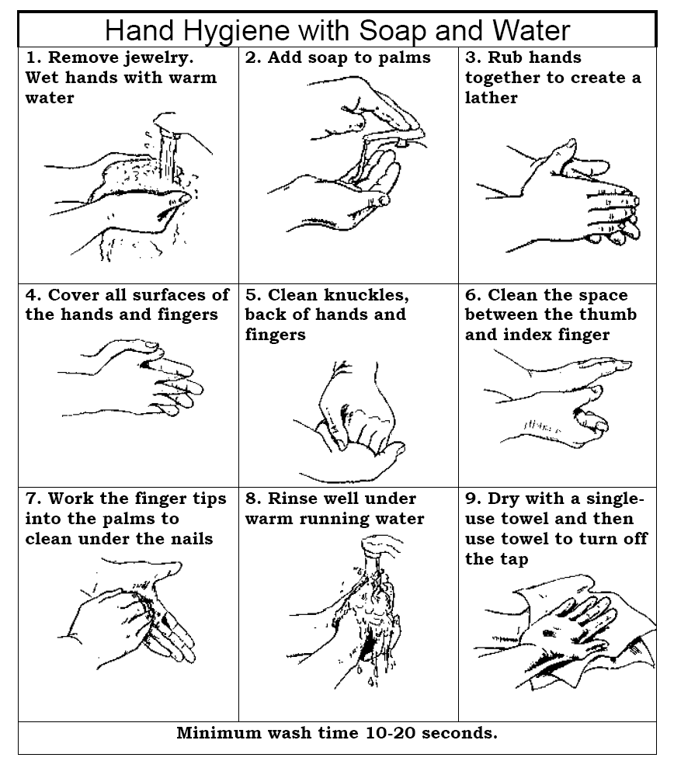
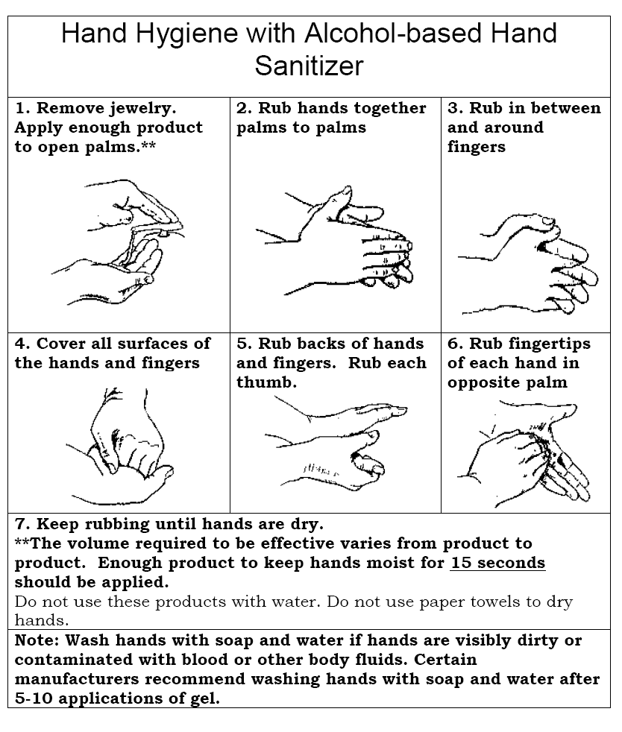
Appendix 3

Virus Infection Notification

Viral infections are contagious.
There is currently an increase in the numbers of people in Australia with a virus infection.
To prevent the spread of the virus at [COMPANY NAME], you must tell your manager if you have any of the following symptoms:

- chills, shivering and a fever
- onset of muscle aches and pains
- sore throat
- dry cough
- trouble breathing
- sneezing
- stuffy or runny nose
- tiredness

If you start to feel ill at work or are showing any of the symptoms listed above,
DO NOT leave your area.

Call your Manager

…………………………………… Phone ext………

Appendix 4: Sample letter to clients

Dear client

A person at [COMPANY NAME] has been confirmed with a viral infection. While this is concerning for everyone, there is no risk to other clients, staff or visitors at [COMPANY NAME].

This disease is managed the same way as other infectious diseases, like mumps, where people who are close contacts – but do not have the disease – are kept away from others, in case they become contagious.

Please understand that people are not considered at risk if they have been close to a contact. However, if you are feeling unwell and have symptoms such as a cough, a high temperature (at least 38°C) and/or shortness of breath.

These symptoms do not necessarily mean you have a viral infection. The symptoms are similar to other illnesses that are much more common, such as a cold and influenza. Shortness of breath is a sign of possible pneumonia and requires immediate medical attention.

If you have these symptoms and have recently been to a country or area of concern, or have been in close contact with someone confirmed with this virus infection, please telephone 13 HEALTH (13 43 25 84) or your doctor immediately.

Yours sincerely

Appendix 5

Screening flowchart

For detection and management of suspected pandemic virus cases

Process
- [COMPANY NAME] receives a call from a client suspecting they may have a viral infection, or from a staff member who has noticed a client who may be ill.
- Avoid contact with the sick person if possible and manage the process over the telephone.
- If a client is ill and requires a visit, follow the flowchart
Defer visit or appointment and document the reason for deferral. Offer phone advice regarding their clinical appointment content
Have you contacted your GP for assessment? If no then recommend they contact their GP.
If an appointment or home visit is necessary if possible arrange appointment to be the last visit of the day and advise the person prior to the appointment that you will be wearing personal protective gear.
During the visit maintain social distancing more than 1m. If you need to be less than 1m from the person wear surgical gloves, gown, surgical mask and eye protection. Perform hand hygiene and reinforce cough, sneeze and hand hygiene with the person
If an appointment or home visit is necessary staff should if possible arrange to be the last appointment of the day and advise the person prior to the visit that you will be wearing personal protection gear
During the visit maintain social distancing (more than 1m. If you need to be less than 1m from the person a surgical mask and gloves should be worn.
During the visit perform hand hygiene and reinforce cough, sneeze and hand hygiene with the person
Phone the person before visit to ask the following questions:
Have you or anyone from your household returned from overseas in the last 14 days?

Was it travel to or from a country or area of concern excluding airport transit?
or
Have you been in close contact with a person with a confirmed communicable disease?

Since the date of potential infection/contact, count 14 days?
Does the visit need to take place within the 14 days since contact?
Do you have a fever or had a history of fever and cough or shortness of breath or a sore throat?

Yes
No
Thank you, arrange visit or appointment as scheduled

No
No
Yes
Yes

